The Multiplication Game

——————————————————————————————————————————

## Set-up:

——————————————————————————————————————————

1. Download the .zip file and extract all the contents
2. *IMPORTANT* Take the .asm files and place them into a folder. This sets up the directory path such that all files can be run simultaneously on MARS.
3. Open MARS (if MARS is not installed on your device, learn how to download and set-up MARS simulator here: <https://courses.missouristate.edu/kenvollmar/mars/>)
4. Click the “open a file for editing” button , and go into the folder that you created that contains the .asm files. Open each file into the simulator.
5. Click on “settings” on the top-left corner of the application (For mac users, click settings from the header line of your mac) and turn on “Assemble all files in directory”.
6. Go into the main file for editing, and assemble the files. From here, you can run the program and play the game in the console.

## How the game works:

——————————————————————————————————————————

The goal of the game is to choose numbers from a 9x9 board and create a row of 4 before the computer does.

A row of 4 can be horizontal, vertical, or even diagonal.

To choose a number from the board, you take the product of two numbers inputted (one from the user and one from the computer).

For example, the computer goes first and chooses to input 9:

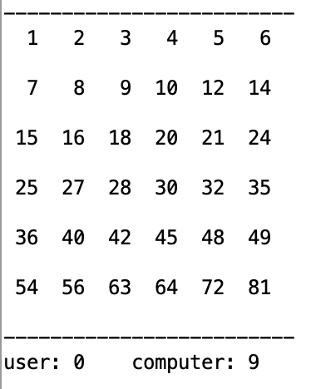

If you want to choose 9 on the board, you input 1, since 1 x 9 = 9.

Your choice is noted by parentheses, and the computer’s are noted by square brackets. The computer plays its next move:

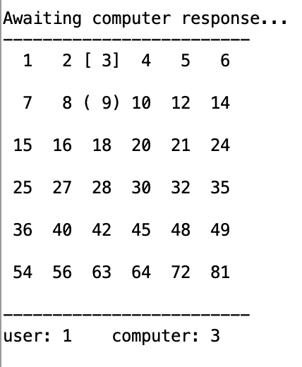

Then it is your turn again. This repeats until the winner gets 4 numbers in a row.

## How-to-play:

——————————————————————————————————————————

1. Run the program, as shown in Set-up.
2. Choose a number between 1-9.
3. Your number (the product) is chosen on the board–wait for the computer’s move
4. After the computer moves, it is your turn again and you repeat steps 2-3.
5. Win or lose!

## Tips:

——————————————————————————————————————————

Make your first choice be near the middle of the board! This expands your opportunities to win with more options to choose from.

If your opponent is close to forming a path, block them! This one really tests your math intuition.

Your move matters just as much to your opponent as it does to you. The computer can only choose a number that is a multiple of your number, so keep that in mind when choosing your next move.

## Miscellaneous:

——————————————————————————————————————————

Invalid input: if you input a number outside of the range 1-9, an error sound plays and a message is displayed to the player which prompts for another input in the proper range.

If you want to exit the game, input the number 0